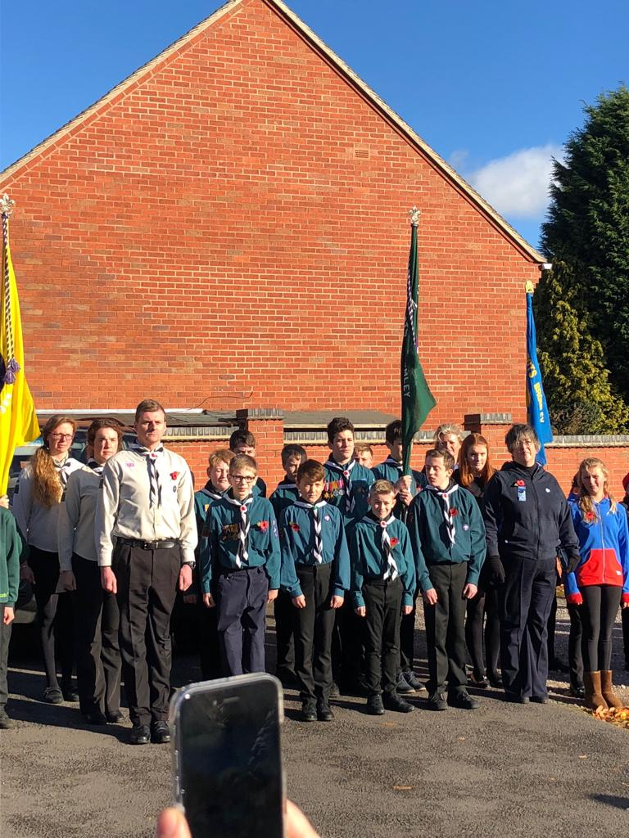

Remembrance Sunday 2018

**scouts.org.uk/join**

**abbotsbromley.scoutsites.org.uk**

#SkillsForLife

Copyright 2019 The Scout Association Registered Charity numbers 306101/SC038437

## In Scouts.…It’s okay to GO FOR IT!

### Girl Scouts!

We are very proud to announce this year we have three new female members of Scouting.

This is the first time we have had female Scouts in Abbots Bromley. We will continue to support the Guides regardless of the fact girls are now eligible to join the Scouts.

/scoutsassociation @UKScouting

# Annual Report 2019

Scouting in Abbots Bromley changed a lot last year, our troop grew from 4 Scouts to 10 Scouts (2017/2018). We have continued that growth this year. We now have a troop of 15 Scouts (2018/2019).

Thank you to each and every one of you. You are part of the bigger picture here.

We are always aiming to make Scouting even better than it is. Fun, teamwork and adventure – those are our three aims. We don’t have to do a lot other than keep a focus on those.

### 1st Abbots Bromley

Lorem ipsum dolor sit amet, consectet ur adipiscing elit. Sed a convallis ex. Cras malesuada neque urna, nec viverra justo porttitor a. Quisque efficitur volutpat magna non luctus. molestie quis in lacus. Donec egestas tempus volutpat.

Morbi porttitor porttitor justo. Morbi eu convallis ante, eget accumsan leo. Nam efficitur iaculis nunc quis vehicula. Curabitur maximus odio eget massa tristique molestie quis in lacus. porta posuere nulla eu. Lorem ipsum dolor sit amet, consectet ur adipiscing elit. Sed a urna, nec viverra justo porttitor.

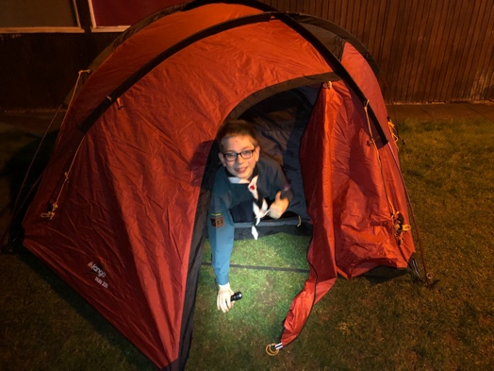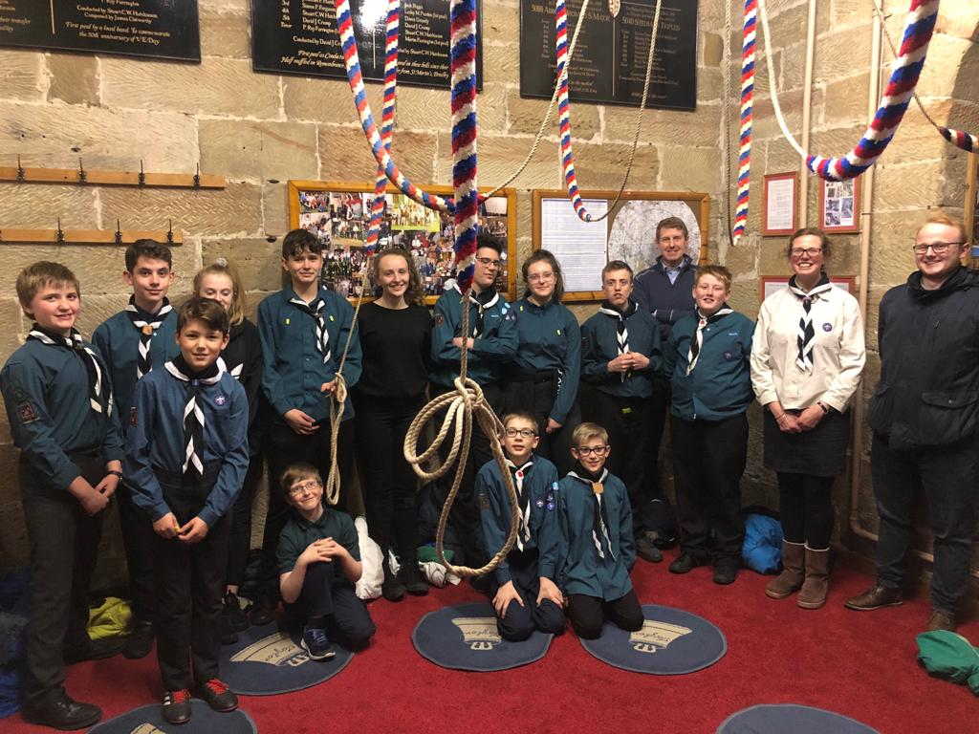

In this report, we are just going to go over a few things we’ve done this year to remind you just how good Scouting really is here in Abbots Bromley.

### Goodbye

It is always sad when we have to say goodbye to members, this year we are saying goodbye to Alfie.

Alfie joined us two years ago and over those two years has been a patrol leader and a role model for the others to look up to.

Alfie will hopefully still join us on camp this year, but we wish Alfie the best of luck in Lichfield Explorers.

## Welcome Carl!

Image caption: Tim Peake lorem ipsum

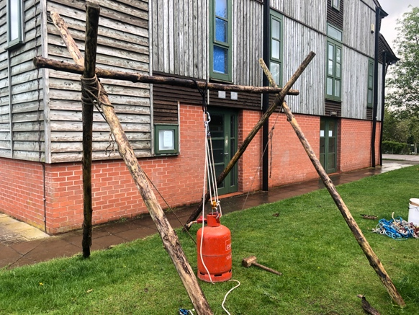

### The New Addition!

### Welcome Carl

We have a new member in our team. Carl recently joined Scouts to help support Louisa, B and Ed with the Thursday night Scout Group.

Carl used to be a Scout himself and has a love for the outdoors. I think Carl fits right in.

### What a great year so far.

We have done some amazing things this year, and we have plenty more to come.

In September we built and raced our very own soap box, this showed great team work. We didn’t just do a good job, we did an amazing one- because Abbots Bromley won the race!

In December we did some very cold, outdoor Tobogganing at Swadlincote dry slope, a brilliant way to finish for Christmas.

January, and with the new year we did some learning. We learned how we could make electronic devices work using only potatoes and lemons. This personally gave me a memory that will last forever – one of our Scouts asked if he could take his Xbox on camp, when I told him there would be no electricity, he told me he would power it with lemons.

February made us hyper with all the sugar we ate from our tour of the Fox’s Biscuit Factory in Uttoxeter. We had a fantastic time and can’t thank Fox’s Biscuits Factory enough!

In March we decided we needed to burn the calories off that we consumed in February at Fox’s. We spent an hour jumping, bouncing, screaming, shouting, falling and laughing at Ninja Warrior in Stoke-on-Trent.

April: Ding-Dong. We were lucky enough to ring the bells at Abbots Bromley Church, see the bells in the bell tower and learn a lot more facts about them.

In May we decided to have a go at doing ropes and pulley systems. One of the questions asked in the bell tower the week before was “How did the bells get up here?”; the answer was ropes and pulleys, no machines or cranes. It was all manual, so we decided to do the same thing.

We are having a camp in June. This is going to be excellent fun! We will be heading to Consall Scout Camp on Friday 14th June and returning Sunday 16th. We will send out further details on this closer to the date.

September 2018 Soap Box Racing

December 2018 Tobogganing

January 2019 Lemon/Potato Power

February 2019 Fox’s Biscuits Factory

March 2019 Ninja Warrior

April 2019 Bell Ringing

May 2019 Ropes & Pullies

## Let’s Reminisce

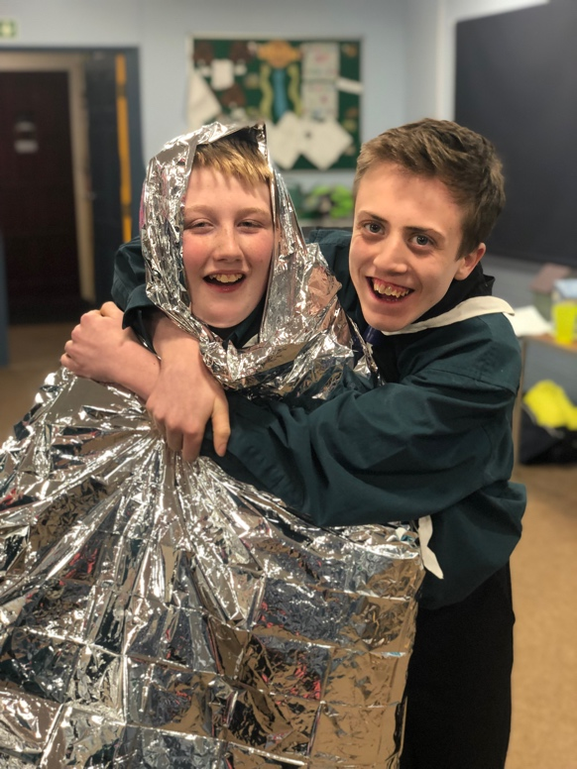

### I’m a Scout!

### GET ME OUT OF HERE

We managed to host a rather entertaining evening, The Scouts were able to eat, mealworms, giant blank ants, red ants, and a few other things – the leaders stayed well away!

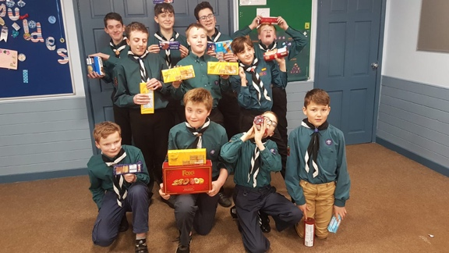

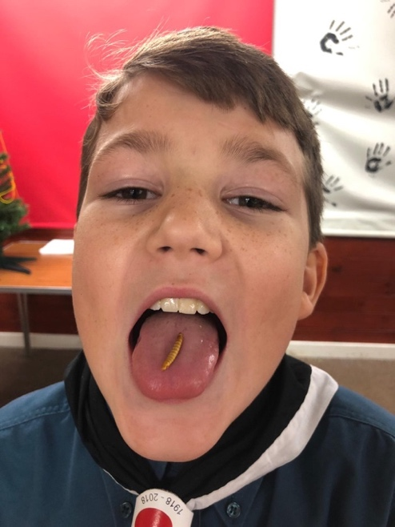

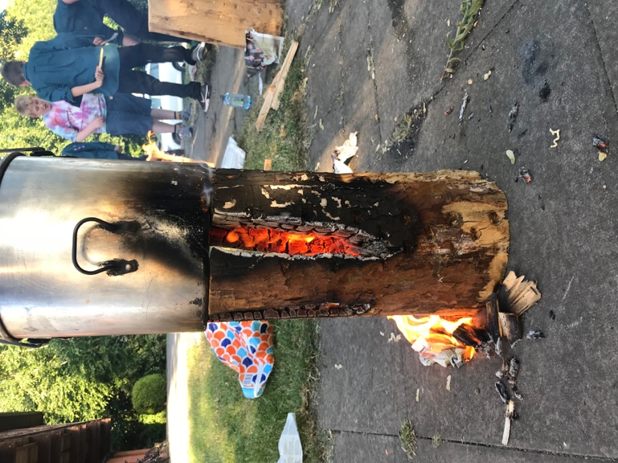

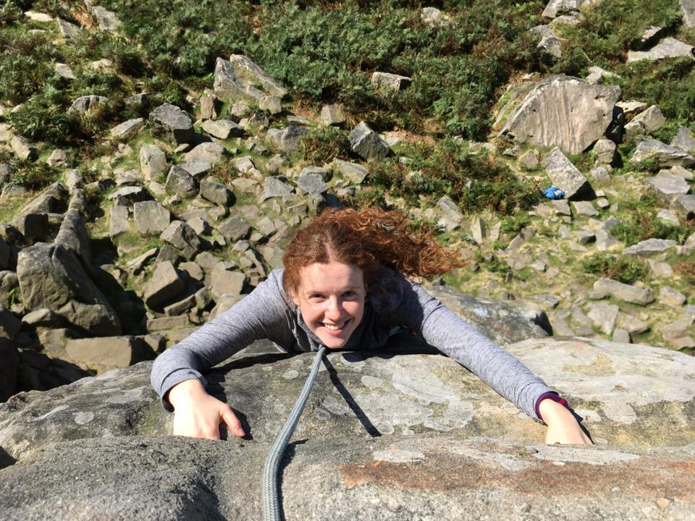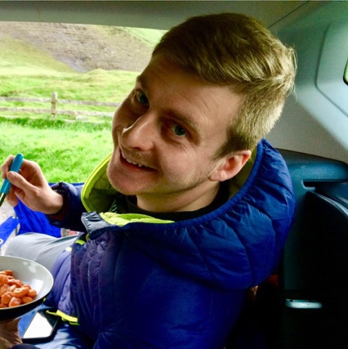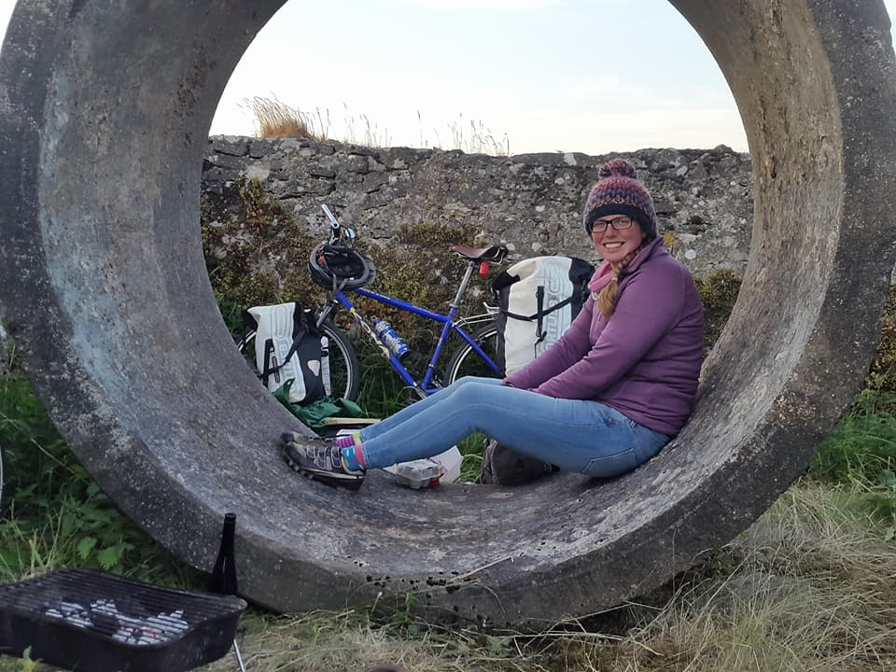

### Bear Grylls Says…



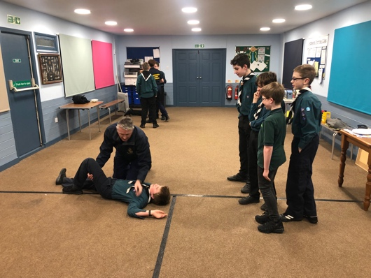

## The Team

### Lou

Lou joined the team in 2017 and has been the backbone of the group when it comes to paperwork. Those forms you sign…Lou probably made them.

Lou has recently struggled to balance Scouting with her other commitments; however, she is REALLY looking forward to getting active again and will be on camp with us.

### Ed

Ed also joined the team in 2017 after a period of being the District’s Network Leader (2014-2017) and being a Cub Scout and Scout prior to that.

In Ed’s personal life he has recently got engaged to Lou – another Scout Leader.

### B

B has been part of the team since 2017 and has been the brains behind some of the amazing activities we have done over the last few years.

She has recently returned to the team after maternity leave, so congratulations to B and her husband Tim on their baby Ranulph.

I do hope we can make a Scout of him…Beaver Leaders watch out!

We can’t do any of this without the support from you. We are funded purely by fundraising.

We have recently spent a small fortune on refurbishing the Scout Hut. The work is on-going.

Tim Veitch has put in a lot of time replacing all the lights and installing a new heating system, meaning in winter the Scout hut is warm when we arrive. We have also installed solar-powered flood lights at the front of the building.

There is also a new paint job. We’re really happy with the more modern blue colour and bright blinds. Do agree?

There is future work planned to replace the kitchen and toilet.

## The Scout Hut Refurb

‘Every child has the right to an adventure. Life is about grabbing opportunities. The prizes don’t always go to the biggest, the best and the strongest – they go to those who persevere. These are simple life lessons that Scouting teaches.’

‘Scouting’s 500,000 members are an inspiration. It's great to see it. It's all about friendship and fun and adventure – people who might not normally have the chance for adventure. Scouts are shining lights in their communities.’

### Thank you from everyone here at Abbots Bromley Scouts